# **Automate updating CST program schedule to Adoption App via Manual Trigger**

This outlines the process to implement automated updating of the Customer Success Training (CST) program schedule.

## **Prerequisites:**

To begin, you will need:

* Adoption App has already been established and all of its instructions, particularly around MS learning Pathways and SPO Lists.

## **Step 1: Setting up Excel File**

* 1. Using the attached excel sheet, have the Retail Store provide CST schedule in this exact format
  + 
  1. Save file in a OneDrive folder supporting your CST trainings
  2. IMPORTANT: Name the file “Active_CST Training Schedule”
  3. Create a Table with current data only
  + [How to Format a Table](https://support.microsoft.com/en-us/office/format-an-excel-table-6789619f-c889-495c-99c2-2f971c0e2370)
  1. Save the file

## **Step 2: Establish Excel and SharePoint connectors**

* 1. While signed into your tenant, browse to the link below for the Microsoft Power Automate template called **Copy an Excel spreadsheet to a SharePoint list template**
  + <https://us.flow.microsoft.com/en-us/galleries/public/templates/c6c74378af884a4bae2b969c8a32c18d/copy-an-excel-spreadsheet-to-a-sharepoint-list/>
  + Once there, click **Try it now**

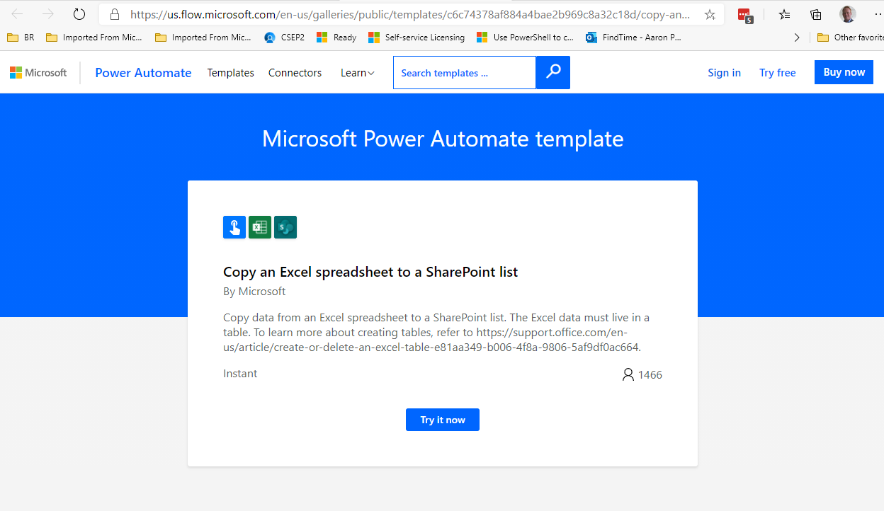

* + Click **Sign In**

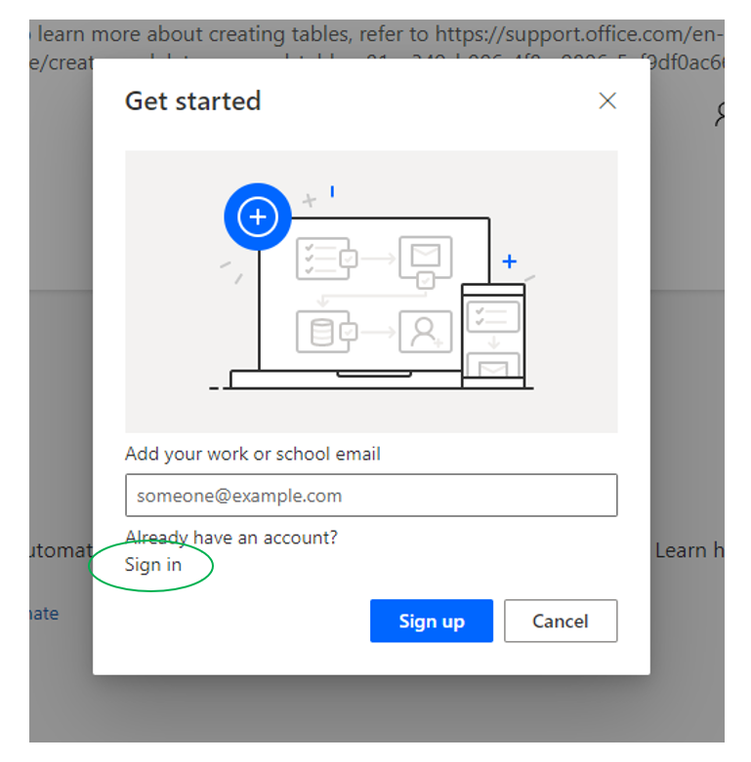

* + Click **Get started**

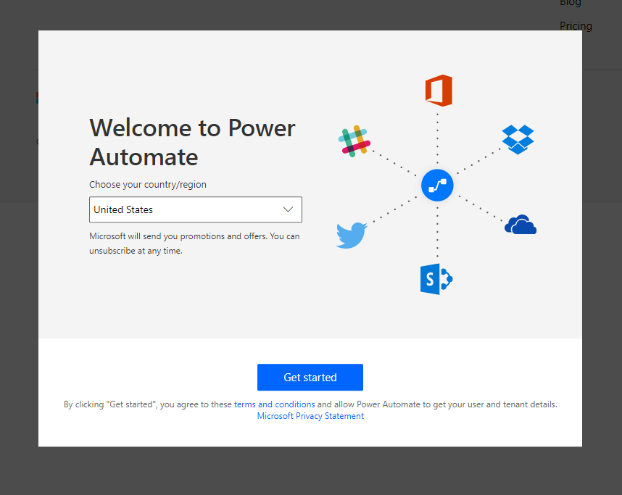

* 1. In the section titled: “**This flow will connect to:**”
  + Click the **+** sign next to **Excel** and select **OneDrive for Business** from the “**Create a new connection**” list

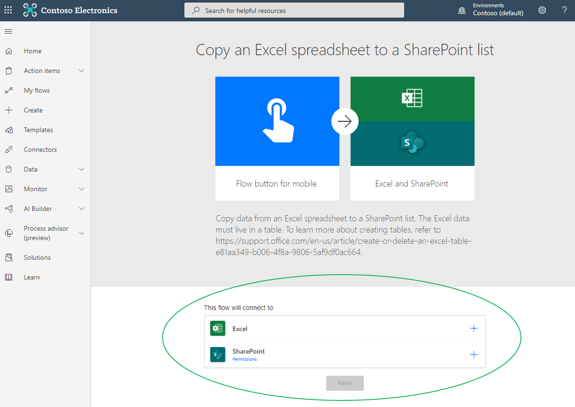

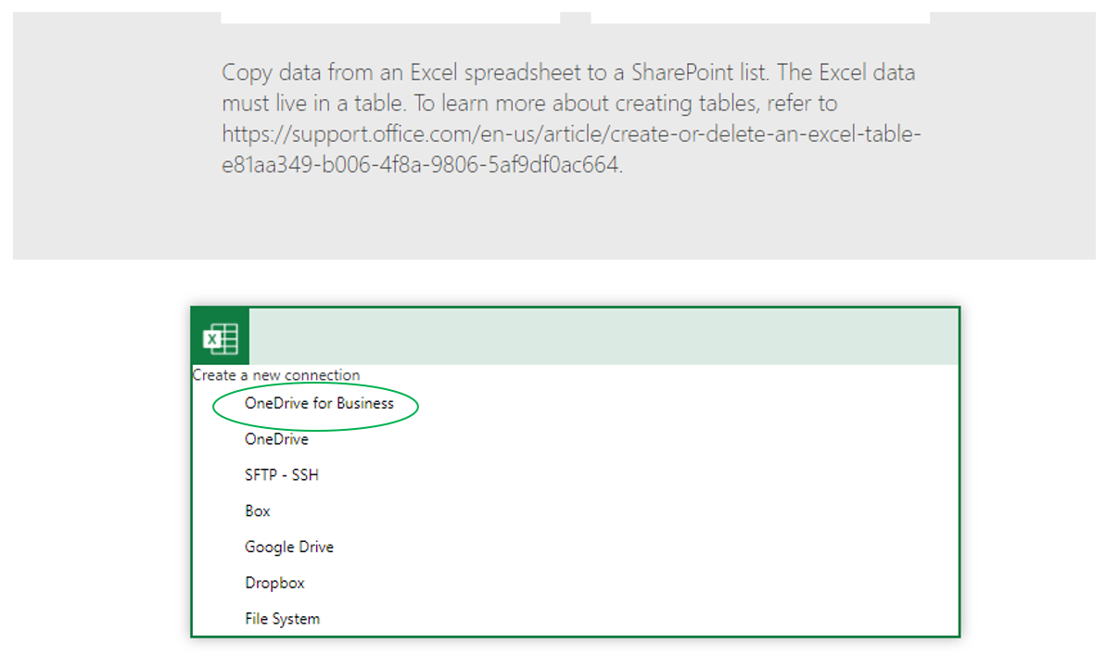

* + - You may need to sign in. Once completed, the following should appear:

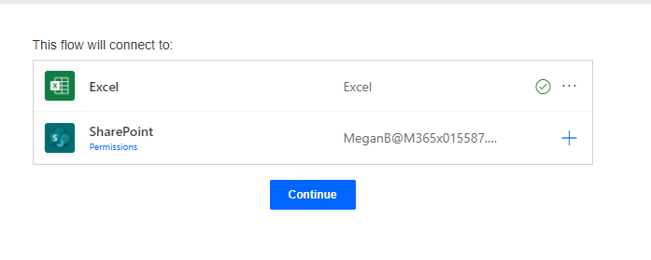

* + Click the **+** sign next to **SharePoint**, log in with user credentials (should be prompted). Once completed, the following should appear:

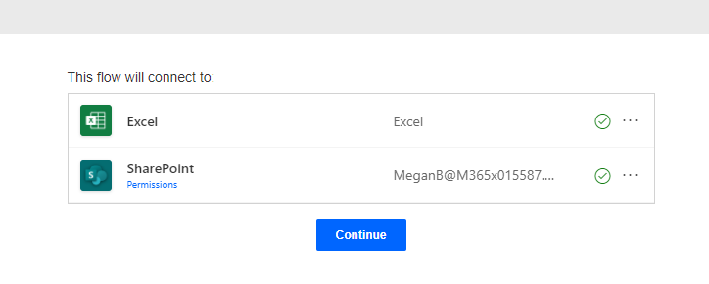

* 1. Click **Continue**
  2. The following should appear:

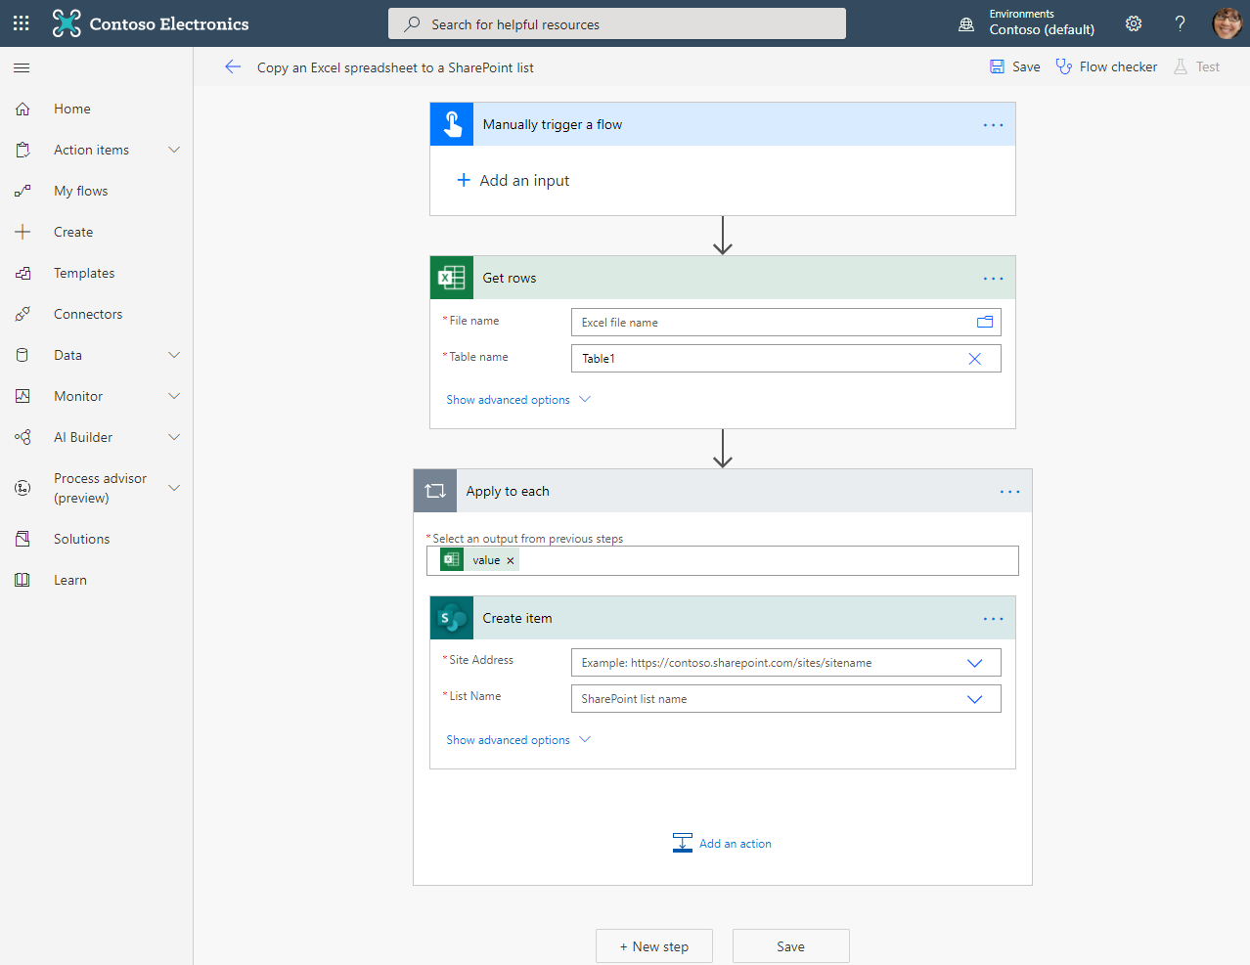

* 1. Click **My flows**
  2. Click OK (you will not need to save this PA template)

## **Step 3: Accessing PowerAutomate template**

* 1. Download Power Automate File (link TBD) - CSTTraining-UpdateSPOListwExcel-DeleteAllAddAll.zip
  2. Open Power Automate [Power Automate | Microsoft Power Platform](https://us.flow.microsoft.com/en-us/)
  3. Click **My flows** from the left navigation bar
  4. Select **Import** from the top menu bar

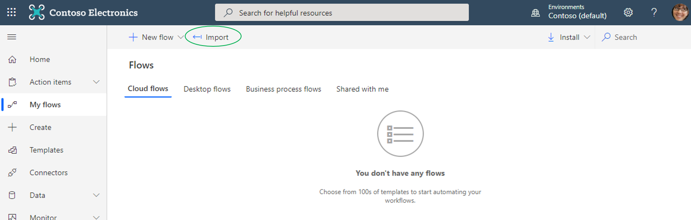

* 1. Select **Upload**

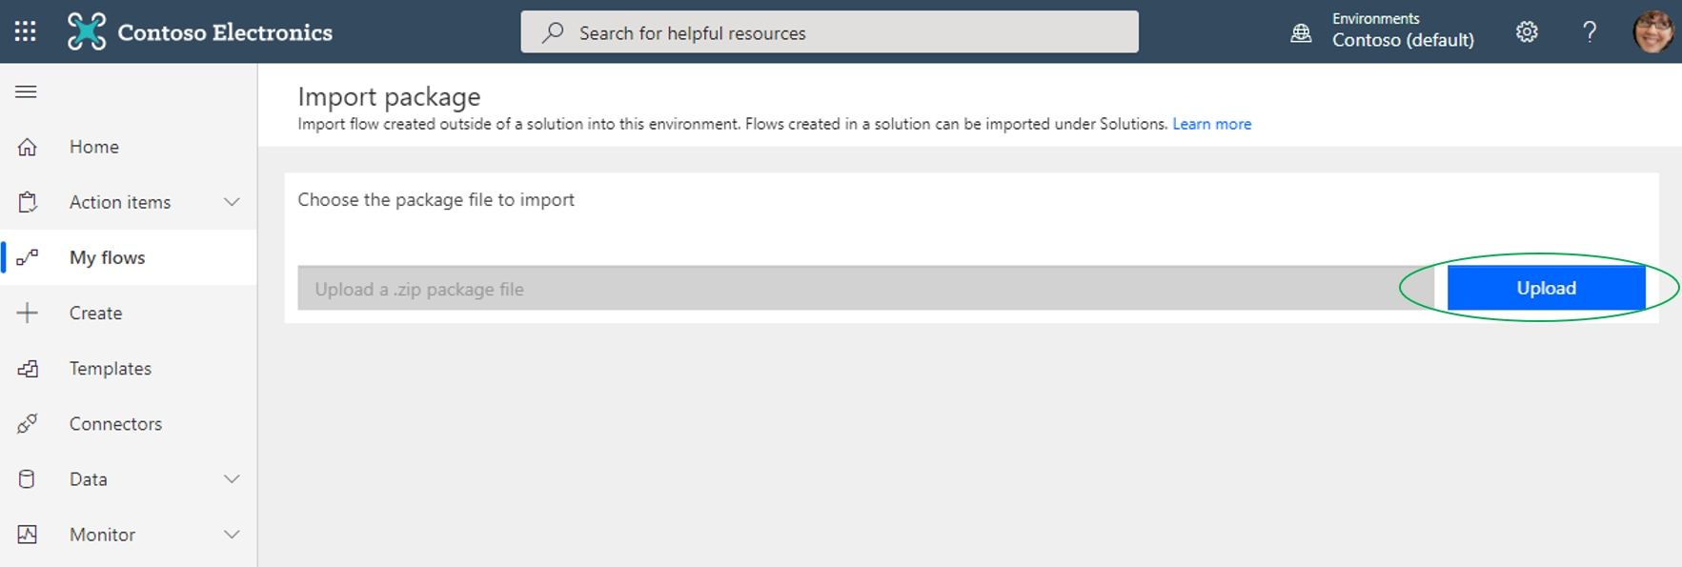

* 1. Find and select the file

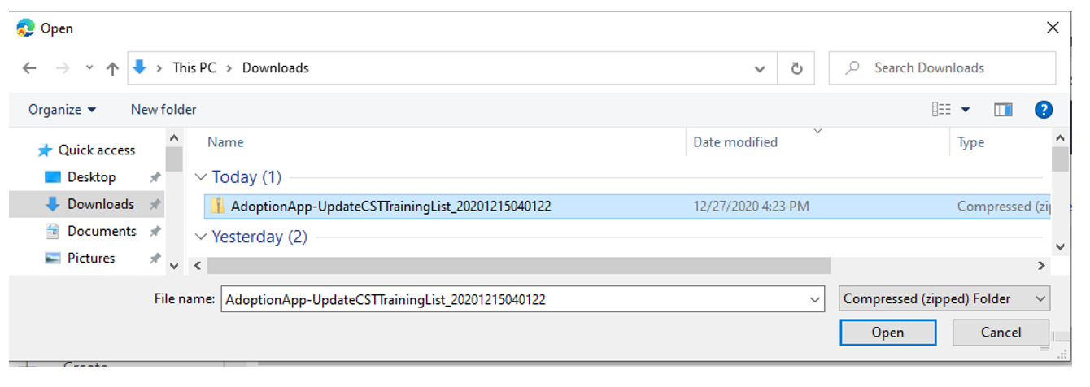

* 1. In the **Review Package Content** section, within the **Choose your import options** area, for Resource Type **Flow**, click **Update**

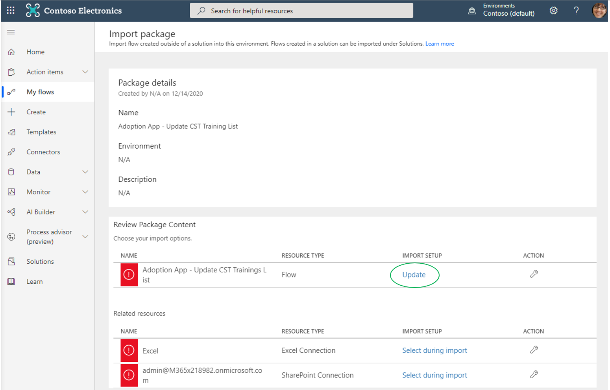

* + In the **Import setup** screen, under **Setup**, select **Create as new**

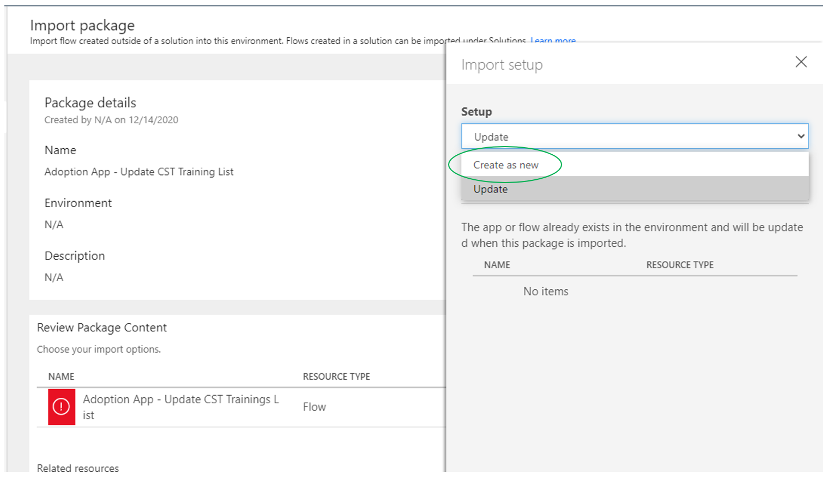

* + In the **Resource name** field, rename to **Adoption App - Update CST Training List**

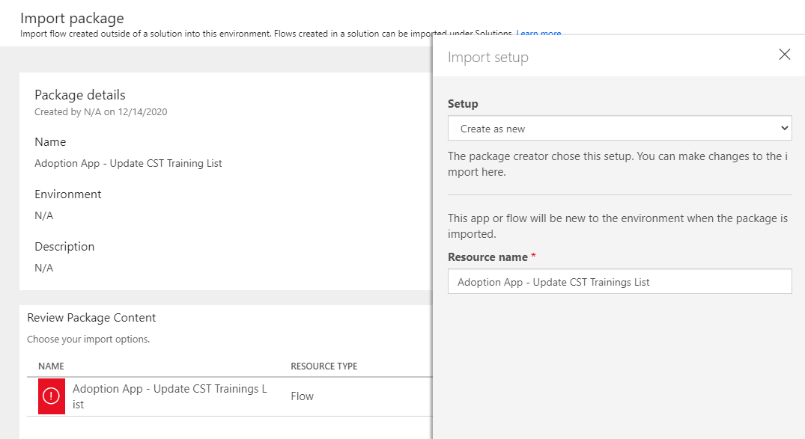

* + Click **Save**
  1. Within the **Related resources** area, for Resource Type **Excel Connection**, click **Select During Import**

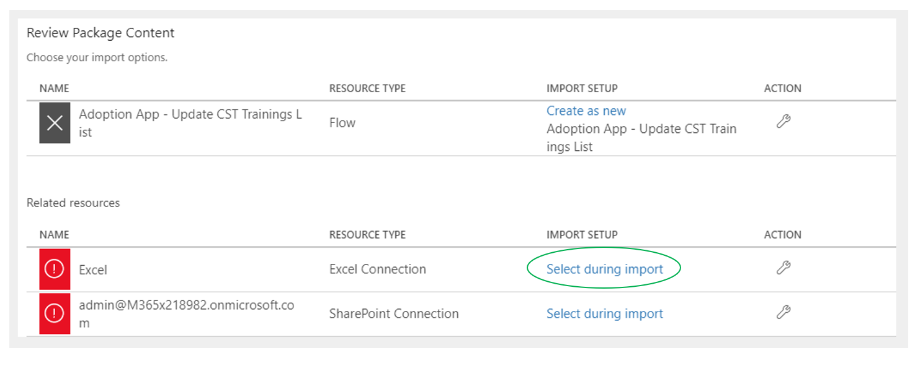

* + Click **Select during Import** from **Setup dropdown**, and select **Excel**

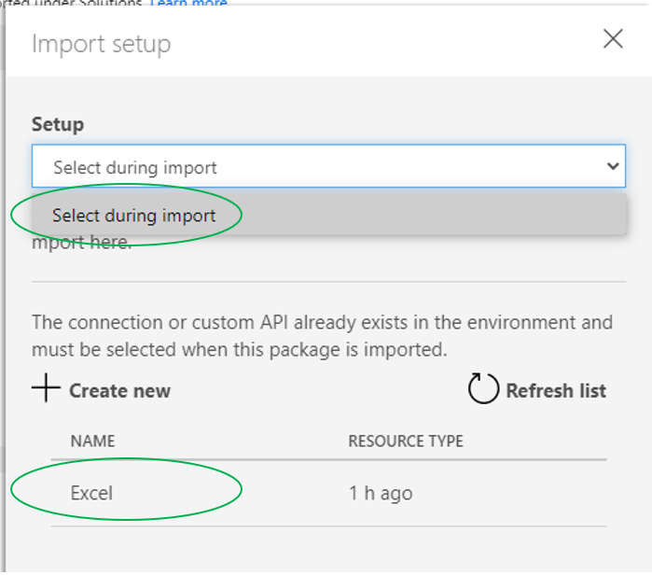

* + Click Save
  1. Within the **Related resources** area, for Resource Type **SharePoint Connection**, click **Select During Import**

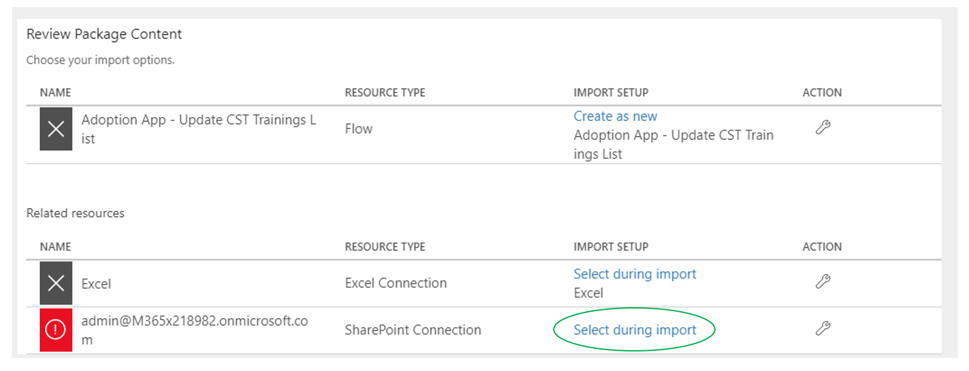

* + Click **Select during Import** from **Setup dropdown**, and select the **Identity** listed

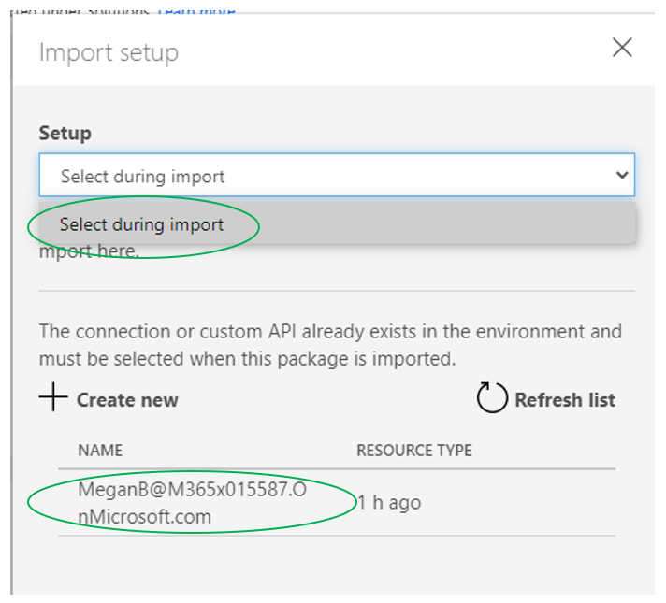

* + Click **Save**
  1. Click **Import**

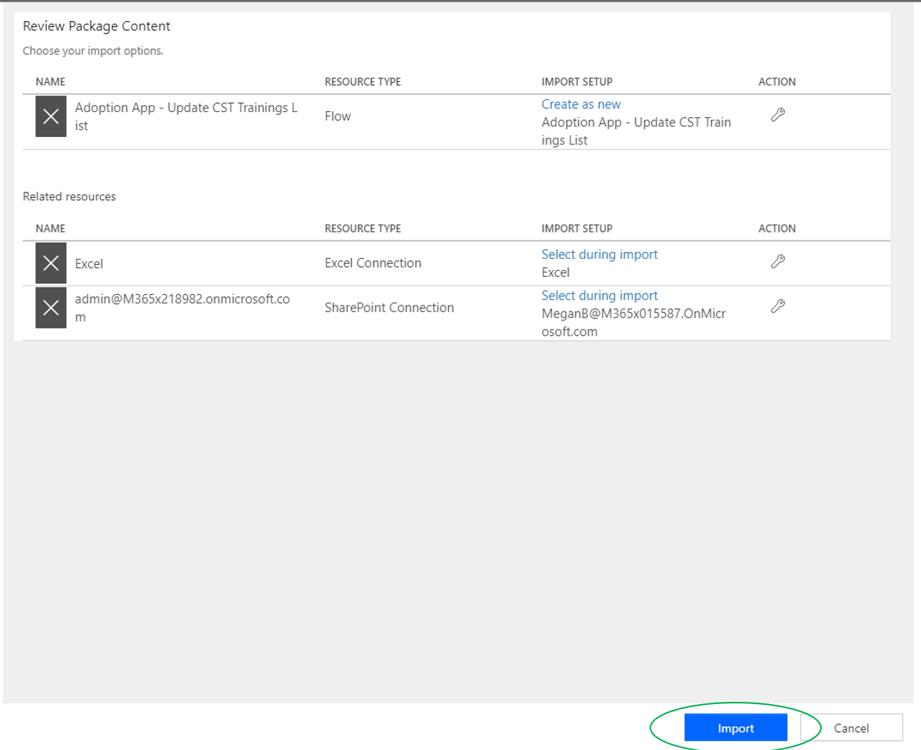

* + The following status message will appear



* + Once completed, the following status message should appear. Click on **Open Flow**

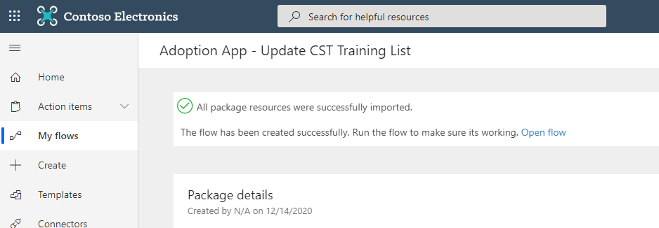

## **Step 4: Configuring PowerAutomate Template**

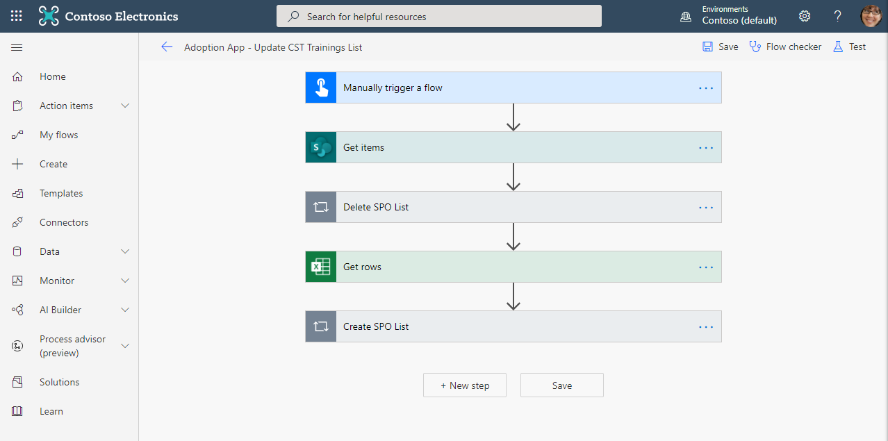 Note all fields throughout PowerAutomate will be prepopulated with demo tenant information. All fields will have to be updated to reflect tenant information where PowerAutomate will be used.

* 1. No changes are required to the **Manually trigger a flow** step
  2. Click the **Get Items** step
  + Site Address
    - Click X to get drop down menu
    - Select MS Learning Pathways from drop down list
  + List Name
    - Click X to get drop down menu
    - Select [List Name] that will host the schedule (should have been completed during Adoption App build)

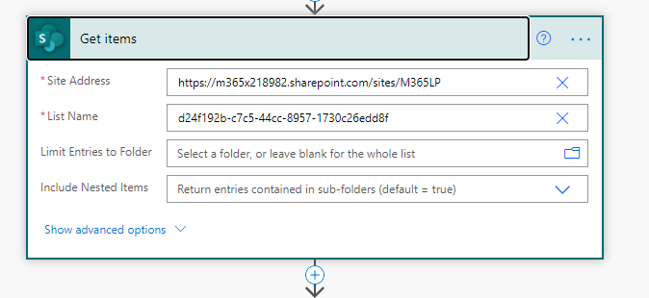

* 1. Click the **Delete SPO list** step
  + Select an output from previous steps
    - Click on the X to remove 
    - From options > Get Items > Select Value (List of Items)
  + Delete Item
    - Site Address
      * Click X to get drop down menu
      * Select MS Learning Pathways from drop down list
    - List Name
      * Click X to get drop down menu
      * Select [List Name] that will host the schedule
    - ID
    - Click on the X to remove 
    - From options > Get Items > Select ID (List item id. …)

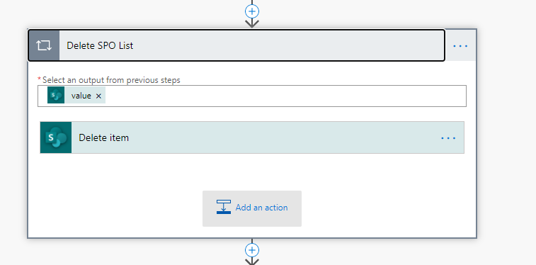

* 1. Get Rows
  + File Name
    - Click on folder
    - Locate your “ACTIVE_CST Training Schedule.xlsx file
  + Table Name
    - Click on drop down to select Table (should only list one)

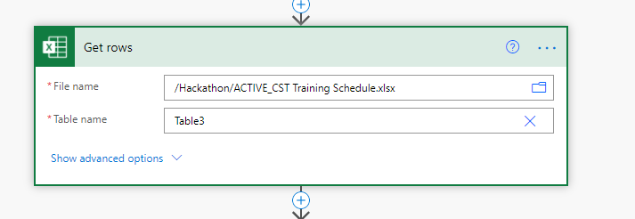

* 1. Create SPO List
  + Select an output from previous steps
    - Click on the X to remove 
    - From options > Get Items > Select Value (List of Items)
  + Create Item
    - Site Address
      * Click X to get drop down menu
      * Select MS Learning Pathways from drop down list
    - List Name
      * Click X to get drop down menu
      * Select [List Name] that will host the schedule
    - Title
      * Click on the X to remove Title
      * From options > Get Rows > Title
    - Date
      * Click on the X to remove Title
      * From options > Get Rows > Date
    - Time
      * Click on the X to remove Title
      * From options > Get Rows > Time
    - Registration
      * Click on the X to remove Title
      * From options > Get Rows > Registration

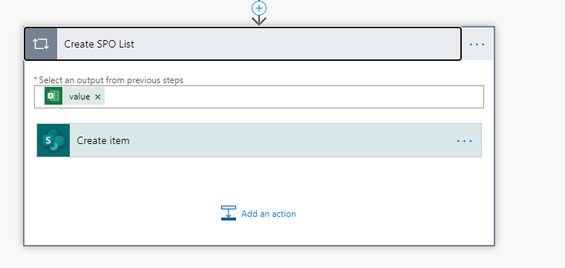

* 1. Click **Save** – Verification of template

## **Step 5: First Run**

* 1. Make sure Excel file ACTIVE, is not open
  2. Run the flow
  3. If successful
  + Verify via the Adoption App > Training Sessions Tab
  + Should see the list of classes

## **Step 5: Updating CST Schedule when new (full active list) is provided by Retail Store**

* 1. Save newly received file in location of ACTIVE_CST Training Schedule.xlsx
  2. Open both files
  3. New File - Select all cells from without header info, copy
  4. ACTIVE File – Select cell A2, paste
  + Delete __PowerAppsId__ Column
  1. Save
  2. Close files
  3. Run PA